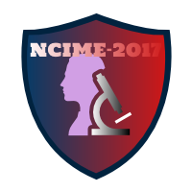

[**Organising Secretary**](7Organising%20Committee/3Organising%20Secretary.docx)

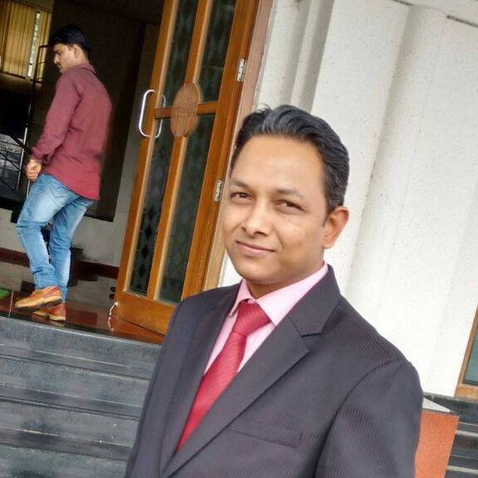

**Dr. V. V. Shinde**

**(Head of Mechanical Engineering Department, SIT, Lonavala)**

***Dear All,***

***Greetings!!***

***I take this opportunity to appeal and welcome you for the participation at the “5th National Conference on Innovations in Mechanical Engineering (NCIME- 2017)” during 17th-18th March, 2017 at Sinhgad Institute of Technology, Lonavala. We emphasis on research activities and publish research papers in National/International, Journal/ Conferences. This National Conference has played vital role in connecting with people and researchers of the National Repute since its inception. The main aim of this Conference is to provide platform to network and share innovations in Mechanical Engineering. This conference is also useful to receive constructive feedback on researchers work and to listen eminent speakers from the nation. Thus you are welcome to become an integral part of the initiative to bring the vision of India 2020 to become a reality.***

***The papers received and accepted in the earlier conferences are published in conference proceedings. This year we have envisioned publishing accepted papers in the high impact factor, indexed journal of international repute. In addition, we offer reimbursement of one way journey travel expenses from your place to conference venue by the shortest route with standard commuting modes limited to train (sleeper coach) and state transport buses. Furthermore, free on campus accommodation will be provided to you to make your stay hassle free in Lonavala. It may interest you that Lonavala is very popular hill station in this part of the country. Post conference, we are also planning for one day tour of Lonavala-Khandala for all registered participants.***

***I am sure that this conference will be the most exciting conference you have attended in recent days. Be a part of the change process.***

***Looking forward to see you in the conference, NCIME-2017.***